

Target: \_\_\_/34 or \_\_\_\_ % 👍 👎

34

**Year 7 HASS- Geography**

***Task 3: In Class Assessment (2.5% weighting)***

***(Livability skills test)***

Name:\_\_\_\_\_\_\_\_\_\_\_\_\_\_\_\_\_\_\_\_\_\_\_\_ Teacher: \_\_\_\_\_\_\_\_\_\_\_\_\_\_\_\_\_\_\_

**Time: 5 minutes reading time and 40 minutes working time.**

**Section 1: Liveability**

1. Define the term ‘liveability’. Provide examples to support your definition.

(2 marks)

\_\_\_\_\_\_\_\_\_\_\_\_\_\_\_\_\_\_\_\_\_\_\_\_\_\_\_\_\_\_\_\_\_\_\_\_\_\_\_\_\_\_\_\_\_\_\_\_\_\_\_\_\_\_\_\_\_\_\_\_\_\_\_\_\_\_\_\_\_\_\_\_\_\_\_\_\_\_\_\_\_\_\_\_\_\_\_\_\_\_\_\_\_\_\_\_\_\_\_\_\_\_\_\_\_\_\_\_\_\_\_\_\_\_\_\_\_\_\_\_\_\_\_\_\_\_\_\_\_\_\_\_\_\_\_\_\_\_\_\_\_\_\_\_\_\_\_\_\_\_\_\_\_\_\_\_\_\_\_\_\_\_\_\_\_\_\_\_\_\_\_\_\_\_\_\_\_\_\_\_\_\_\_\_\_\_\_\_\_\_\_\_\_\_\_\_\_\_\_\_\_\_\_\_\_\_\_\_\_\_\_\_\_\_\_\_\_\_\_\_\_\_\_\_\_\_\_\_\_\_\_\_\_\_\_\_\_\_\_\_\_\_\_\_\_\_\_\_\_\_\_\_\_\_\_\_\_\_\_\_\_\_\_\_\_\_\_\_\_\_\_\_\_\_\_\_\_\_\_\_\_\_\_\_

1. Look at the two photographs of the same laneway in Melbourne in 1994 and 2004. The laneway is in a central location in the central business district, close to one of the major railway stations.

|  |  |
| --- | --- |
| Macintosh HD:Users:sofijastefanovic:Desktop:PGEO_PR7_Ts8_02.jpg |  |
| **Source 1:**  *Melbourne Laneway 1994* | **Source 2:**  *Melbourne Laneway 2004* |

1. Look carefully at Source 1, the Melbourne laneway in **2004**.
2. Describe **two** positive aspects of living in this place. (2 marks)

\_\_\_\_\_\_\_\_\_\_\_\_\_\_\_\_\_\_\_\_\_\_\_\_\_\_\_\_\_\_\_\_\_\_\_\_\_\_\_\_\_\_\_\_\_\_\_\_\_\_\_\_\_\_\_\_\_\_\_\_\_\_\_\_\_\_\_\_\_\_\_\_\_\_\_\_\_\_\_\_\_\_\_\_\_\_\_\_\_\_\_\_\_\_\_\_\_\_\_\_\_\_\_\_\_\_\_\_\_\_\_\_\_\_\_\_\_\_\_\_\_\_\_\_\_\_\_\_\_\_\_\_\_\_\_\_\_\_\_\_\_\_\_\_\_\_\_\_\_\_\_\_\_\_\_\_\_\_\_\_\_\_\_\_\_\_\_\_\_\_\_\_\_\_\_\_\_\_\_\_\_\_\_\_\_\_\_\_\_\_\_\_\_\_\_\_\_\_\_\_\_\_\_\_\_\_\_\_\_\_\_\_\_\_\_\_\_\_\_\_\_\_\_\_\_\_\_\_\_\_\_\_\_\_\_\_\_\_\_\_\_\_\_\_\_\_\_\_\_\_\_\_\_\_\_\_\_\_\_\_\_\_\_\_\_\_\_\_\_\_\_\_

1. Describe **two** negative aspects of living in this place. (2 marks)

\_\_\_\_\_\_\_\_\_\_\_\_\_\_\_\_\_\_\_\_\_\_\_\_\_\_\_\_\_\_\_\_\_\_\_\_\_\_\_\_\_\_\_\_\_\_\_\_\_\_\_\_\_\_\_\_\_\_\_\_\_\_\_\_\_\_\_\_\_\_\_\_\_\_\_\_\_\_\_\_\_\_\_\_\_\_\_\_\_\_\_\_\_\_\_\_\_\_\_\_\_\_\_\_\_\_\_\_\_\_\_\_\_\_\_\_\_\_\_\_\_\_\_\_\_\_\_\_\_\_\_\_\_\_\_\_\_\_\_\_\_\_\_\_\_\_\_\_\_\_\_\_\_\_\_\_\_\_\_\_\_\_\_\_\_\_\_\_\_\_\_\_\_\_\_\_\_\_\_\_\_\_\_\_\_\_\_\_\_\_\_\_\_\_\_\_\_\_\_\_\_\_\_\_\_\_\_\_\_\_\_\_\_\_\_\_\_\_\_\_\_\_\_\_\_\_\_\_\_\_\_\_\_\_\_\_\_\_\_\_\_\_\_\_\_\_\_\_\_\_\_\_\_\_\_\_\_\_\_\_\_\_\_\_\_\_\_\_\_\_\_\_

1. Compare Source 1 the Melbourne laneway in **1994** to Source 2 the laneway in **2004**. Which would be the more liveable of the two? Explain why. (3 marks)

(**Hint:** A good answer will include words such as **whereas** and **however**)

\_\_\_\_\_\_\_\_\_\_\_\_\_\_\_\_\_\_\_\_\_\_\_\_\_\_\_\_\_\_\_\_\_\_\_\_\_\_\_\_\_\_\_\_\_\_\_\_\_\_\_\_\_\_\_\_\_\_\_\_\_\_\_\_\_\_\_\_\_\_\_\_\_\_\_\_\_\_\_\_\_\_\_\_\_\_\_\_\_\_\_\_\_\_\_\_\_\_\_\_\_\_\_\_\_\_\_\_\_\_\_\_\_\_\_\_\_\_\_\_\_\_\_\_\_\_\_\_\_\_\_\_\_\_\_\_\_\_\_\_\_\_\_\_\_\_\_\_\_\_\_\_\_\_\_\_\_\_\_\_\_\_\_\_\_\_\_\_\_\_\_\_\_\_\_\_\_\_\_\_\_\_\_\_\_\_\_\_\_\_\_\_\_\_\_\_\_\_\_\_\_\_\_\_\_\_\_\_\_\_\_\_\_\_\_\_\_\_\_\_\_\_\_\_\_\_\_\_\_\_\_\_\_\_\_\_\_\_\_\_\_\_\_\_\_\_\_\_\_\_\_\_\_\_\_\_\_\_\_\_\_\_\_\_\_\_\_\_\_\_\_\_\_\_\_\_\_\_\_\_\_\_\_\_\_\_\_\_\_\_\_\_\_\_\_\_\_\_\_\_\_\_\_\_\_\_\_\_\_\_\_\_\_\_\_\_\_\_\_\_\_\_\_\_\_\_\_\_\_\_\_\_\_\_\_\_\_\_\_\_\_\_\_\_\_\_\_\_\_\_\_\_\_\_\_\_\_\_\_\_\_\_\_\_\_\_\_\_\_\_\_\_\_\_\_\_\_\_\_\_\_\_\_\_\_\_\_\_\_\_\_\_\_\_\_\_\_\_\_\_\_\_\_\_\_\_\_\_

1. The table below shows the ranking results of Mercer’s Quality of Living Survey for 2018 for the top 20 cities. Refer to the list and answer the questions that follow.

|  |  |  |
| --- | --- | --- |
| **Rank** | **City** | **Country** |
| 1 | Vienna | Austria |
| 2 | Zurich | Switzerland |
| 3 | Auckland | New Zealand |
| 4 | Munich | Germany |
| 5 | Vancouver | Canada |
| 6 | Dusseldorf | Germany |
| 7 | Frankfurt | Germany |
| 8 | Geneva | Switzerland |
| 9 | Copenhagen | Denmark |
| 10 | Basel | Switzerland |
| 10 | Sydney | Australia |
| 12 | Amsterdam | Netherlands |
| 13 | Berlin | Germany |
| 14 | Bern | Switzerland |
| 15 | Wellington | New Zealand |
| 16 | Melbourne | Australia |
| 16 | Toronto | Canada |
| 18 | Luxembourg | Luxembourg |
| 19 | Ottawa | Canada |
| 19 | Hamburg | Germany |

*Source:* [*www.imercer.com*](http://www.imercer.com)

1. How many Australian cities are ranked in the top 20? Name them. (2 marks)

\_\_\_\_\_\_\_\_\_\_\_\_\_\_\_\_\_\_\_\_\_\_\_\_\_\_\_\_\_\_\_\_\_\_\_\_\_\_\_\_\_\_\_\_\_\_\_\_\_\_\_\_\_\_\_\_\_\_\_\_\_\_\_\_\_\_\_\_\_\_\_

1. What was the world’s most liveable city in 2018? (1 mark)

\_\_\_\_\_\_\_\_\_\_\_\_\_\_\_\_\_\_\_\_\_\_\_\_\_\_\_\_\_\_\_\_\_\_\_\_\_\_\_\_\_\_\_\_\_\_\_\_\_\_\_\_\_\_\_\_\_\_\_\_\_\_\_\_\_\_\_\_\_\_\_

1. What was Canada’s most liveable city? (1 mark)

\_\_\_\_\_\_\_\_\_\_\_\_\_\_\_\_\_\_\_\_\_\_\_\_\_\_\_\_\_\_\_\_\_\_\_\_\_\_\_\_\_\_\_\_\_\_\_\_\_\_\_\_\_\_\_\_\_\_\_\_\_\_\_\_\_\_\_\_\_\_\_

1. What country has the same amount of liveable cities as Australia in the top 20? Name both of the cities from this country that feature in the top 20. (3 marks)

Country:\_\_\_\_\_\_\_\_\_\_\_\_\_\_\_\_\_\_\_\_\_\_\_\_\_\_\_\_\_\_\_\_\_\_\_\_\_\_\_\_

City 1: \_\_\_\_\_\_\_\_\_\_\_\_\_\_\_\_\_\_\_\_\_\_\_\_\_\_\_\_\_\_\_\_\_\_\_\_\_\_\_\_\_

City 2: \_\_\_\_\_\_\_\_\_\_\_\_\_\_\_\_\_\_\_\_\_\_\_\_\_\_\_\_\_\_\_\_\_\_\_\_\_\_\_\_\_\_

**Section 2: Where Australians live**

Look at Source 3, the population density map for Australia below and then answer the questions below;

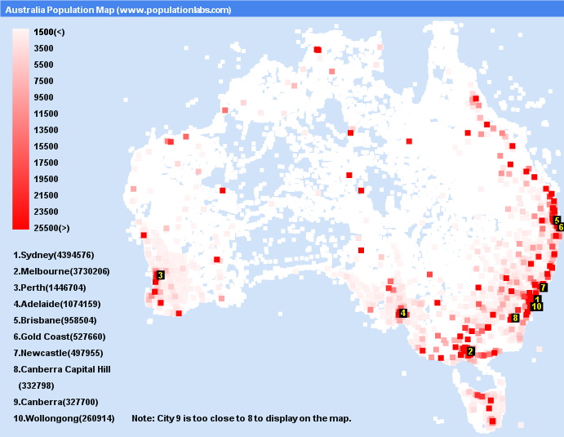

**Source 3:**

1. Using Source 3 above, what are **two** patterns that you notice about where most Australians live. (2 marks)

\_\_\_\_\_\_\_\_\_\_\_\_\_\_\_\_\_\_\_\_\_\_\_\_\_\_\_\_\_\_\_\_\_\_\_\_\_\_\_\_\_\_\_\_\_\_\_\_\_\_\_\_\_\_\_\_\_\_\_\_\_\_\_\_\_\_\_\_\_\_\_\_\_\_\_\_\_\_\_\_\_\_\_\_\_\_\_\_\_\_\_\_\_\_\_\_\_\_\_\_\_\_\_\_\_\_\_\_\_\_\_\_\_\_\_\_\_\_\_\_\_\_\_\_\_\_\_\_\_\_\_\_\_\_\_\_\_\_\_\_\_\_\_\_\_\_\_\_\_\_\_\_\_\_\_\_\_\_\_\_\_\_\_\_\_\_\_\_\_\_\_\_\_\_\_\_\_\_\_\_\_\_\_\_\_\_\_\_\_\_\_\_\_\_\_\_\_\_\_\_\_\_\_\_\_\_\_\_\_\_\_\_\_

1. Outline some reasons why people choose to live in these particular areas.

*(****Hint****: A good response will refer to social, infrastructure, cultural, environmental and economic forces that influence liveability)* (4 marks)

\_\_\_\_\_\_\_\_\_\_\_\_\_\_\_\_\_\_\_\_\_\_\_\_\_\_\_\_\_\_\_\_\_\_\_\_\_\_\_\_\_\_\_\_\_\_\_\_\_\_\_\_\_\_\_\_\_\_\_\_\_\_\_\_\_\_\_\_\_\_\_\_\_\_\_\_\_\_\_\_\_\_\_\_\_\_\_\_\_\_\_\_\_\_\_\_\_\_\_\_\_\_\_\_\_\_\_\_\_\_\_\_\_\_\_\_\_\_\_\_\_\_\_\_\_\_\_\_\_\_\_\_\_\_\_\_\_\_\_\_\_\_\_\_\_\_\_\_\_\_\_\_\_\_\_\_\_\_\_\_\_\_\_\_\_\_\_\_\_\_\_\_\_\_\_\_\_\_\_\_\_\_\_\_\_\_\_\_\_\_\_\_\_\_\_\_\_\_\_\_\_\_\_\_\_\_\_\_\_\_\_\_\_\_\_\_\_\_\_\_\_\_\_\_\_\_\_\_\_\_\_\_\_\_\_\_\_\_\_\_\_\_\_\_\_\_\_\_\_\_\_\_\_\_\_\_\_\_\_\_\_\_\_\_\_\_\_\_\_\_\_\_\_\_\_\_\_\_\_\_\_\_\_\_\_\_\_\_\_\_\_\_\_\_\_\_\_\_\_\_\_\_\_\_\_\_\_\_\_\_\_\_\_\_\_\_\_\_\_\_\_\_\_\_\_\_\_\_\_\_\_\_\_\_\_\_\_\_\_\_\_\_\_\_\_\_\_\_\_\_\_\_\_\_\_\_\_\_\_\_\_\_\_\_\_\_\_\_\_\_\_\_\_\_\_\_\_\_\_\_\_\_\_\_\_\_\_\_\_\_\_\_\_\_\_\_\_\_\_\_\_\_\_\_\_\_\_\_\_\_\_\_\_\_\_\_\_\_\_\_\_\_\_\_\_\_\_\_\_\_\_\_\_\_\_\_\_\_\_\_\_\_\_\_\_\_\_\_\_\_\_\_\_\_\_\_\_\_\_\_\_\_\_\_\_\_\_\_\_\_\_\_\_\_\_\_\_\_\_\_\_\_\_\_\_\_\_\_\_\_\_\_\_\_\_\_\_\_\_\_\_\_\_\_\_\_\_\_\_\_\_\_\_\_\_\_\_\_\_\_\_\_\_\_\_\_\_\_\_\_\_\_\_\_\_\_\_\_\_\_\_\_\_\_\_\_\_\_\_\_\_\_\_\_\_\_\_\_\_\_\_\_\_\_\_\_\_\_\_\_\_\_\_\_\_\_\_\_\_\_\_\_\_\_\_\_\_\_\_\_\_\_\_\_\_\_\_\_\_\_\_\_\_\_\_\_\_\_\_\_\_\_\_\_\_\_\_\_\_\_\_\_\_\_\_\_\_\_\_\_\_\_\_\_\_\_\_\_\_

**Section 3: Sketch Map**

Using Source 4, the map provided to you draw a sketch map of Narrogin.

You must include BOLTSS. The border has been drawn for you.

* You must **neatly** include, (using suitable colours):
* Narrogin Senior High School
* Narrogin Primary School
* Coles

(12 marks)

* Great Southern Highway
* Narrogin Railway
* Narrogin Speedway

LEGEND

**Source 4:**

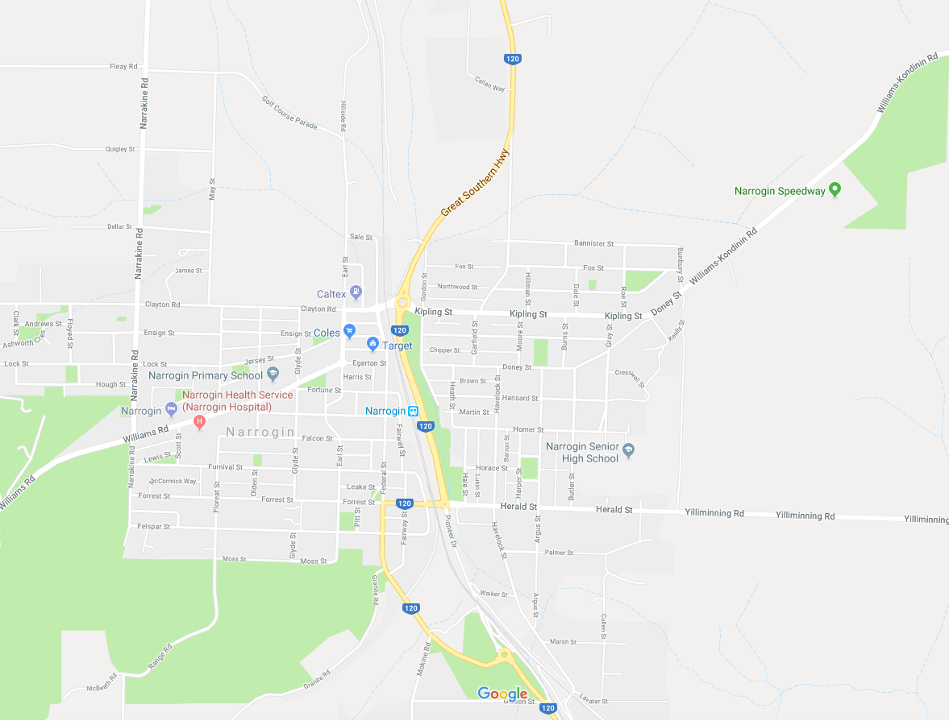



[Type a quote from the document or the summary of an interesting point. You can position the text box anywhere in the document. Use the Drawing Tools tab to change the formatting of the pull quote text box.]

[Type a quote from the document or the summary of an interesting point. You can position the text box anywhere in the document. Use the Drawing Tools tab to change the formatting of the pull quote text box.]